**1.GIT – HOL**

The objective of this lab is to get familiar with Git commands like git init, git status, git add, git commit, git push, and git pull.

We follow the following steps to complete this handson.

**Steps :**

1. **Configure Git in my computer :-**
2. Check if Git is installed –

We run the following command in Git Bash to check if the Git is installed.

1. Set the Git username and email –

git config --global user.name "Shreya Singh Patel"

git config --global user.email "shreyasavtanpatel7@gmail.com"

1. Verify your settings –

1. **Integrate notepad++.exe to Git and make it a default editor :-**
2. Test if Notepad++ opens from Git Bash –

1. Create an alias for Notepad++ in Git Bash –

1. Set Notepad++ as Git’s default editor –



1. Verify the editor setting –



1. **Create a Local Git Repository :-**
2. Make a new folder –



1. Verify it –

1. **Add a File to the Repository :-**
2. Create a new file and verify it –



1. View file contents –

1. Check Git status –

1. Stage the file –

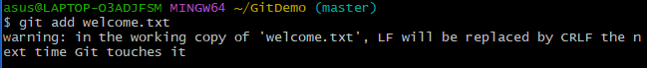

1. Commit the file –

1. **Push to GitHub :-**
2. Create a repository on GitHub (name it GitDemo).
3. Link local repo to the remote repo –



1. Push local changes to GitHub –

1. **Verify :-**

